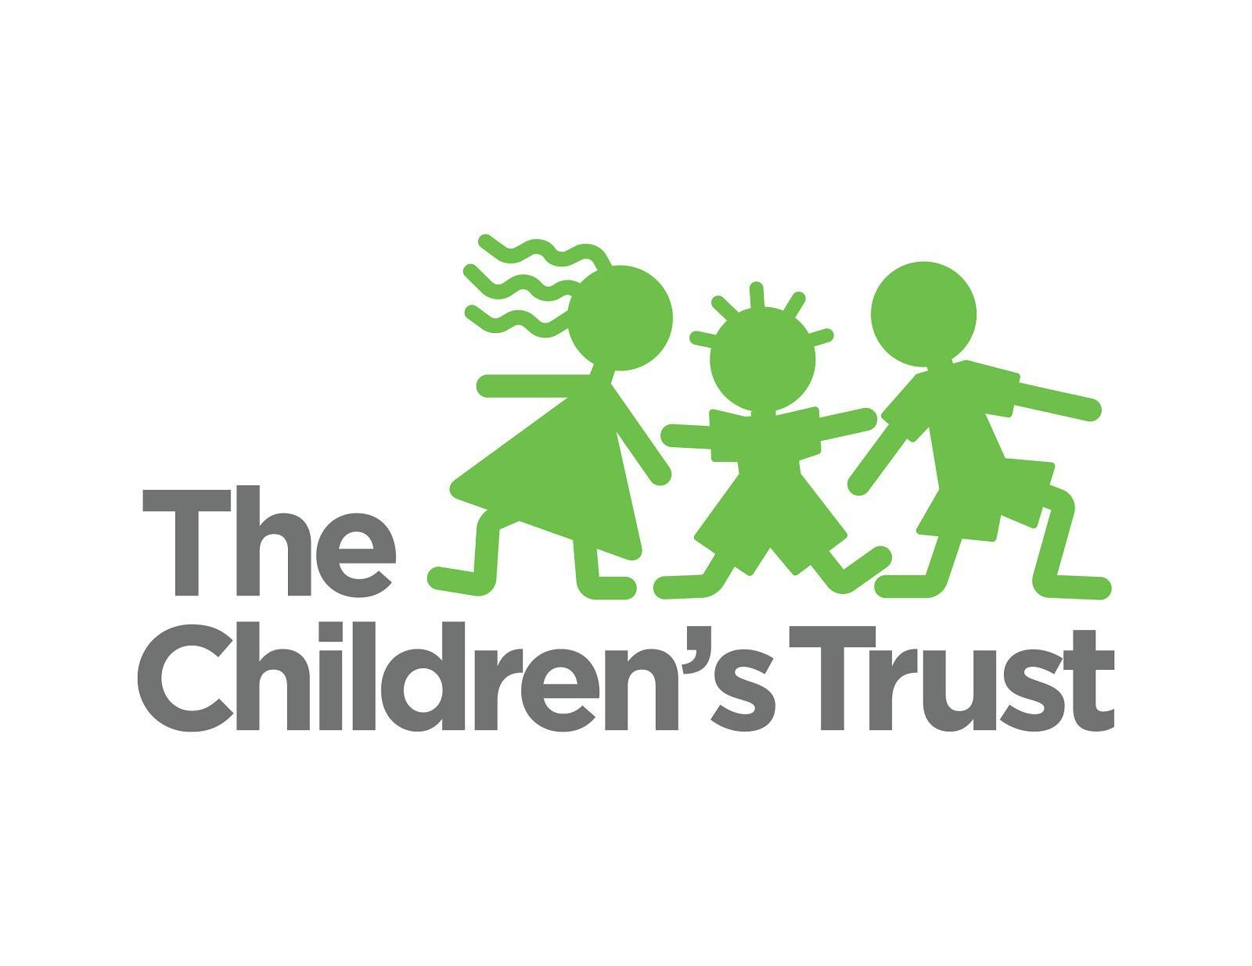

Community Outreach & Broadcast/Print Publicity Report

March 1, 2018 – April 5, 2018

Board Meeting: Monday, April 16, 2018

This report (with live links) may be downloaded from the April 16, 2018, board meeting page on our
community calendar.

The Children’s Trust in the Community

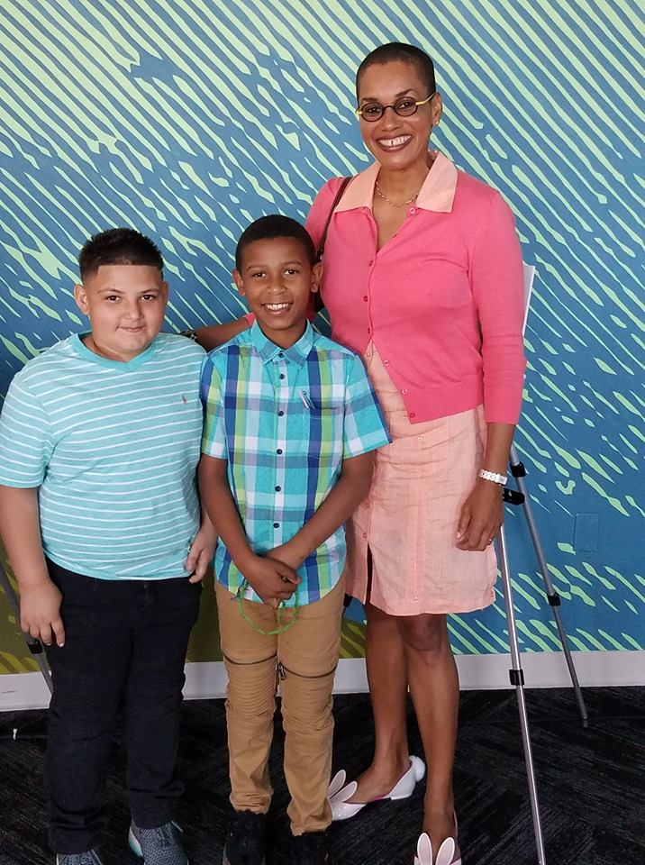
March 26, Miami

Accepting a volunteer of the year award from Trust-funded provider Urgent, at the agency’s third annual “This Woman’s Work” event.

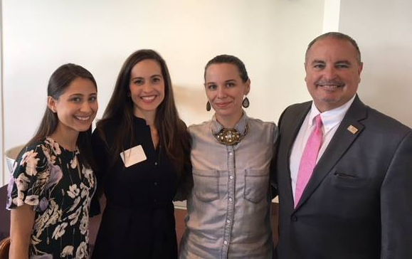
March 19, Miami

At the League of Miami-Dade County “4th Annual Women That Shine” celebration.

PUBLICITY
April 5
Miami Herald
Reach: 6,000,000
Heart gallery aims to ‘find forever families’ for children hoping to be adopted
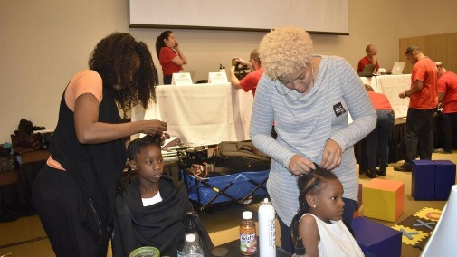

April 5
South Florida Times
Reach: 4,000
3rd annual “This Woman’s Work” honors individuals and organizations
Trust provider, Urgent Inc., honors Trust staffer Stephanie Sylvestre as a volunteer of the year
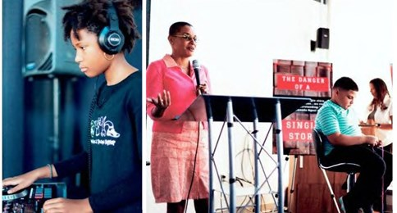

April 3
Diario las Americas
Reach: 150,000
María Lucía Rojas acerca la ciencia a los niños de Miami con mucha diversión
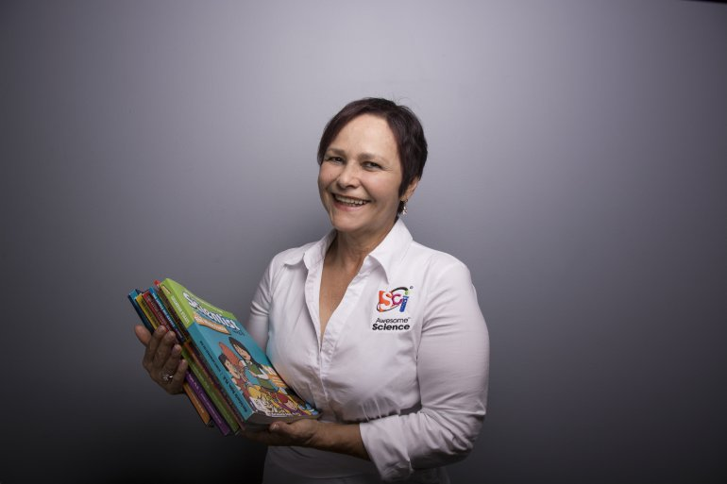
“Awesome Science” a children’s science program, mentions Trust as a partner
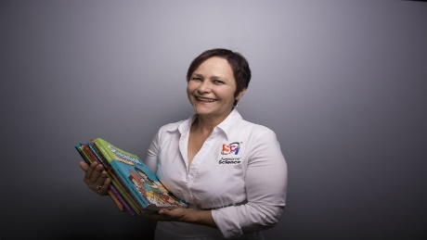

April 3
Caribbean Today
Reach: N/A
The Other Mozart comes to South Miami Dade Cultural Arts Center
Trust mentioned as funder of the Miami-Dade County Department of Cultural Affairs

March 29
WSVN Channel 7 News
Reach: 186,000
Photo shoot held for over 25 foster children in Miami
The Children’s Trust Miami Heart Gallery featured

March 29
WFOR Channel 4 News
Reach:
Four Young Siblings In Foster Care Hope To Find Their Forever Parents In South Florida
The Children’s Trust Miami Heart Gallery featured

March 26
Miami’s Community Newspapers
Reach: 8,000
“THE BOOK OF PSALMS” DANCE PERFORMANCE INSPIRED BY BIBLICAL VERSE Dance NOW!
Trust mentioned as funder of Dance Now!

March 21
Miami Herald
Reach: 6,000,000
Tips for raising a resilient child who doesn’t fall apart at the seams
Feature byline: Trust staffer Rachel Spector
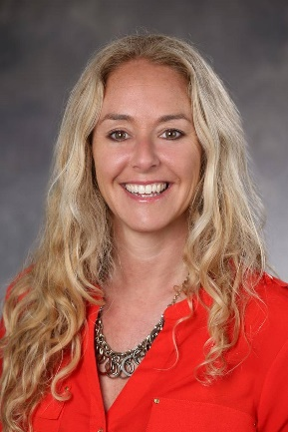

March 14
The Miami Times
Reach: 2,000
Kids, it’s time to show your talent and dream big
Trust Young Talent Big Dreams talent competition promoted

March 13
Miami’s Community Newspapers
Reach: 8,000
Commissioner hosts Funders’ Forum for District 8 Nonprofit Academy grads
Trust mentioned as a forum participant
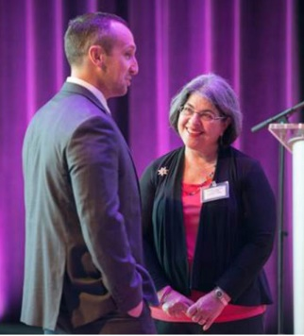

March 8
Miami Herald
Reach: 6,000,000
Intention is what distinguishes a ‘teller’ from a ‘tattler’
Feature byline: Trust staffer Lori Hanson
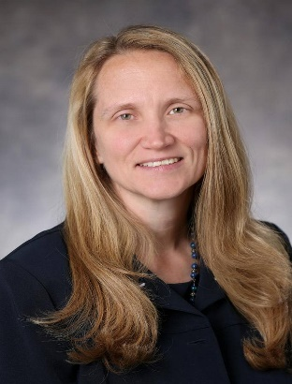

March 7
Miami’s Community Newspapers
Reach: 8,000
Spring into fitness and adventures at Miami-Dade Parks’ Spring Break Camps, March 26-30

District 11 E-Newsletter promotes The Children’s Trust spring break camps for children with disabilities

March 5
Miami’s Community Newspapers
Reach: 8,000
Annual Young Talent Big Dreams competition returning this spring
Young Talent Big Dreams featured

March 1
The Westside Gazette
Reach: 1,000
The 3rd Annual ‘This Woman’s Work’ Event honors eight leaders and organizations that serve and uplift the community
Trust provider, Urgent Inc., honors Trust staffer, Stephanie Sylvestre as a volunteer of the year
